1.Random Forest classification
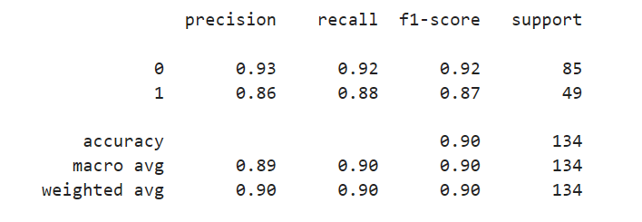
Questions:
1. What is the percentage of overall performance? – 0.90
2. What is the correct performance of purchased? – 0.88
3. What is the correct performance of not purchased? – 0.92
4. What is the correct and wrongly classified performance of purchased? – 0.86
5. What is the correct and wrongly classified performance of not purchased? – 0.93
6. What is the overall performance of not purchased? – 0.92
7. What is the overall performance of purchased? – 0.87
8. What is the average performance of precision? – 0.89
9. What is the average performance of recall? – 0.90
10. What is the average performance of F1-measure? – 0.90
11. What is the sum of product of proportion rate (weight) of each class?
Precision – 0.90; Recall – 0.90; F1-measure – 0.90
12. What is the total count in the test set? – 134
13. What is the total count of not purchased in the test set? – 85
14. What is the total count of purchased in the test set? - 49

